**Day-45 practice (17/10/2024)**

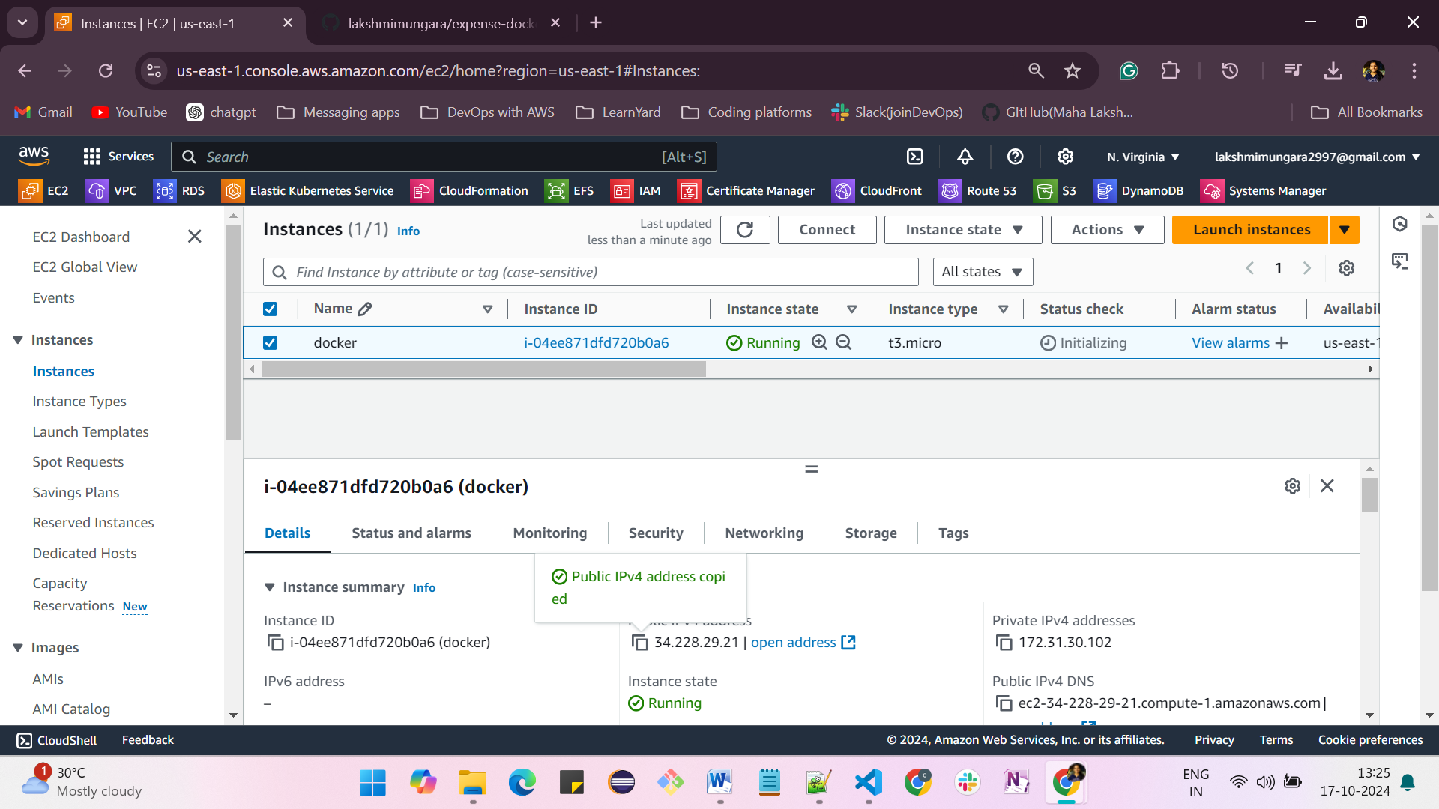

#!/bin/bash

LOGS_FOLDER="/var/log/docker"

SCRIPT_NAME=$(echo $0 | cut -d "." -f1)

TIMESTAMP=$(date +%Y-%m-%d-%H-%M-%S)

LOG_FILE="$LOGS_FOLDER/$SCRIPT_NAME-$TIMESTAMP.log"

mkdir -p $LOGS_FOLDER

USERID=$(id -u)

R="\e[31m"

G="\e[32m"

N="\e[0m"

Y="\e[33m"

# Ensure the script is run as root or using superuser

if [ "$USERID" -ne 0 ]; then

  echo -e "${R}Please run with root user privileges or use sudo.${N}"

  exit 1

else

  echo -e "${G}Running with root user privileges.${N}"

fi

# Step 1: Update the package manager and install dependencies

echo -e "${Y} installing dependencies...${N}"

yum install -y yum-utils &>>$LOG_FILE

# Step 2: Add Docker repository

echo -e "${G}Adding Docker repository...${N}"

yum-config-manager --add-repo https://download.docker.com/linux/rhel/docker-ce.repo &>>$LOG_FILE

# Step 3: Install Docker

echo -e "${Y}Installing Docker...${N}"

yum install -y docker-ce docker-ce-cli containerd.io docker-buildx-plugin docker-compose-plugin &>>$LOG_FILE

# Step 4: Start Docker service

echo -e "${Y}Starting Docker service...${N}"

systemctl start docker &>>$LOG_FILE

if [ $? -eq 0 ]; then

  echo -e "${G}Docker service started successfully!${N}"

else

  echo -e "${R}Failed to start Docker service.${N}"

  exit 1

fi

# Enable Docker service to start at boot

echo -e "${Y}Enabling Docker service at boot...${N}"

systemctl enable docker &>>$LOG_FILE

if [ $? -eq 0 ]; then

  echo -e "${G}Docker is enabled to start on boot.${N}"

else

  echo -e "${R}Failed to enable Docker to start on boot.${N}"

fi

# Step 5: Verify Docker installation

echo -e "${G}Verifying Docker installation...${N}"

docker --version

if [ $? -eq 0 ]; then

  echo -e "${G}Docker installed successfully!${N}"

else

  echo -e "${R}Docker installation failed!${N}"

  exit 1

fi

# Step 6: Add the current user to the docker group (optional)

echo -e "${Y}Adding the current user to the docker group to avoid using sudo...${N}"

usermod -aG docker ec2-user

if [ $? -eq 0 ]; then

  echo -e "${G}User added to the docker group.${N}"

else

  echo -e "${R}Failed to add user to the docker group.${N}"

fi

# Finally

echo -e "${G}Docker is installed and running.${N}"

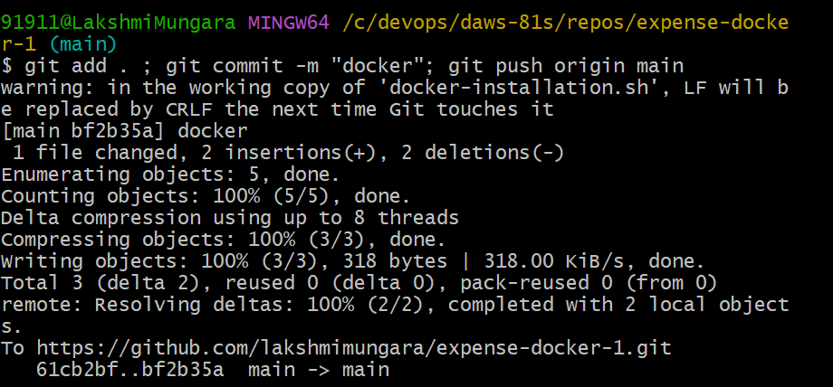

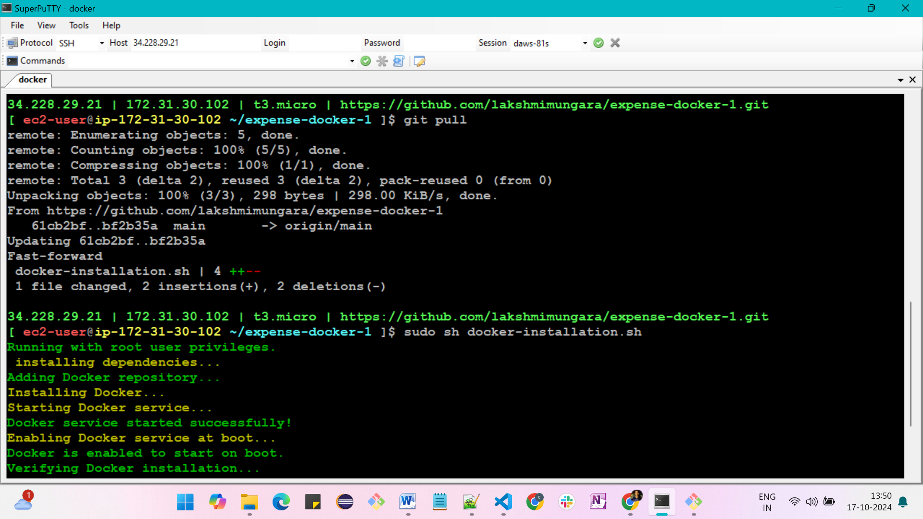

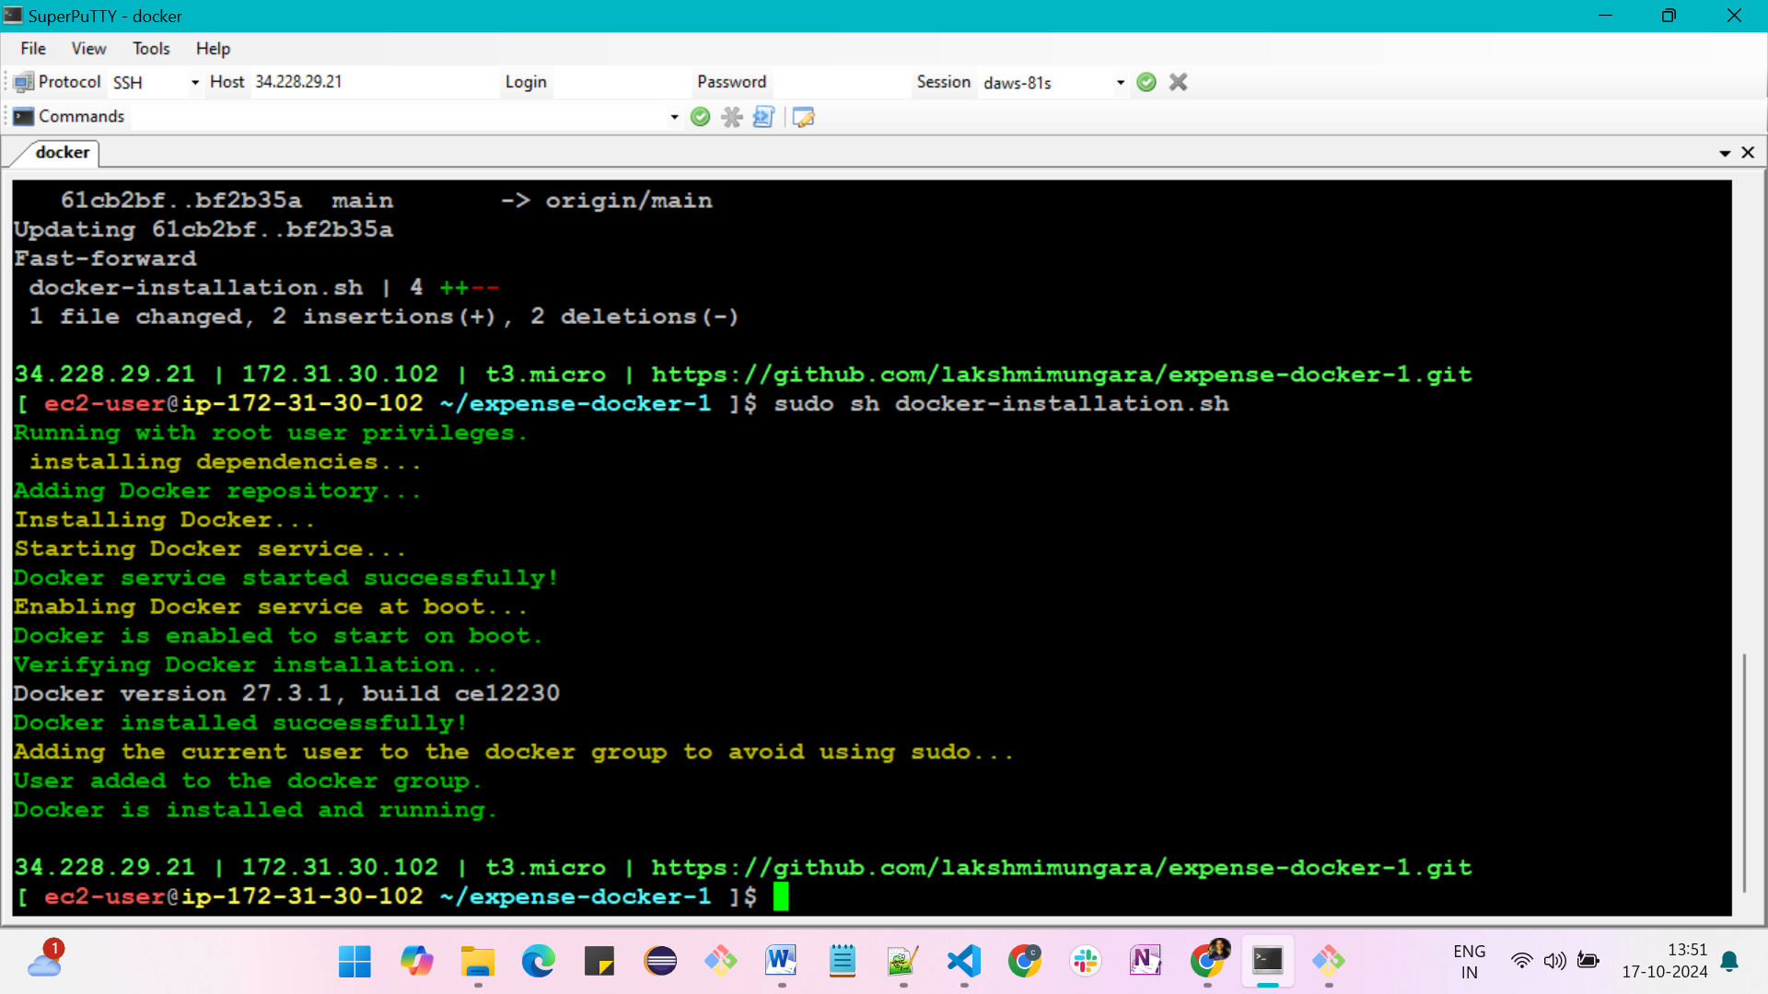

**After installing docker, remember to logout and login again and check if it works fine with the following**

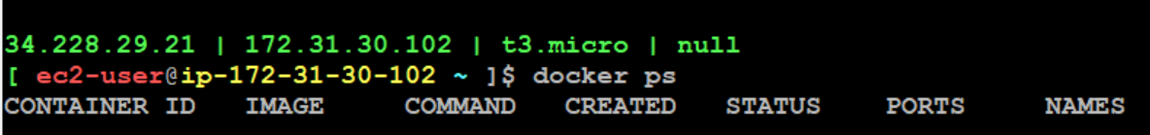

**Mysql**

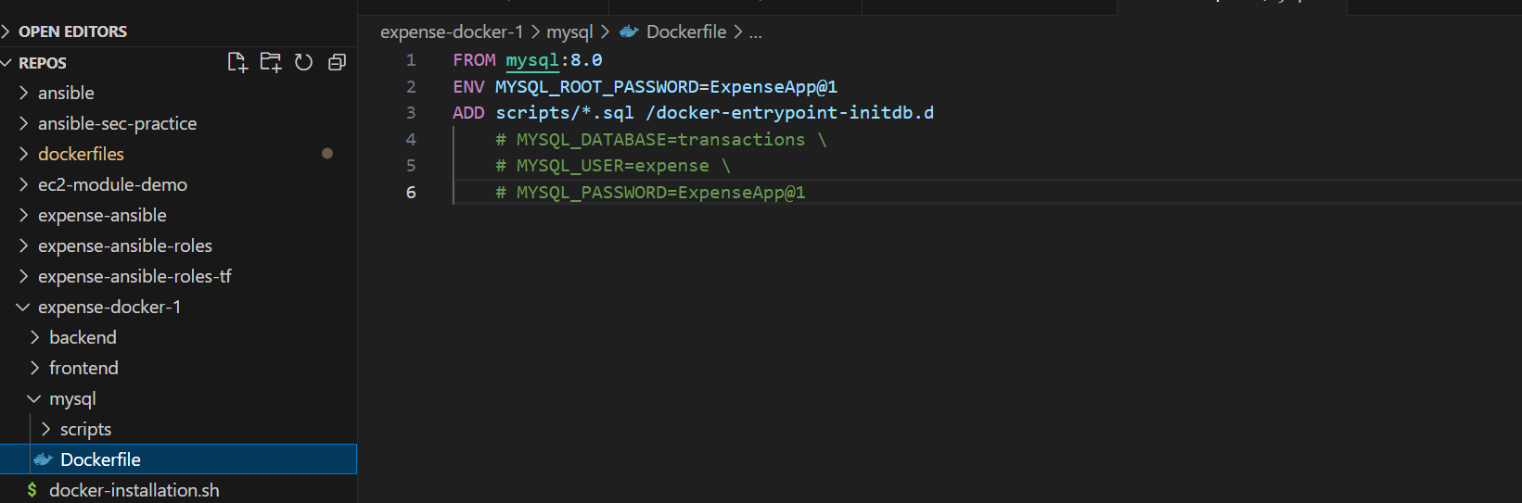

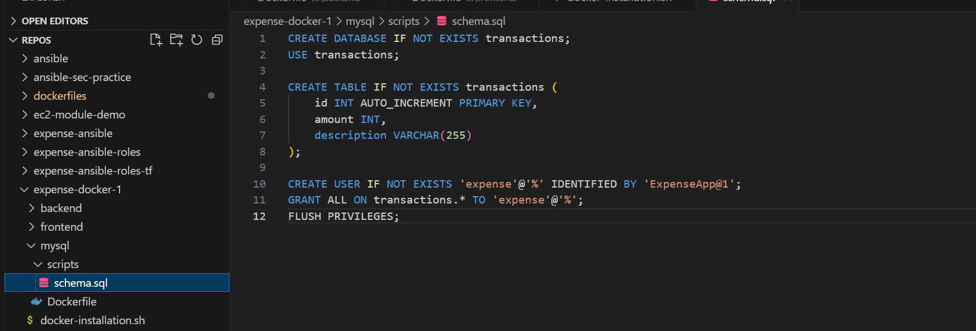

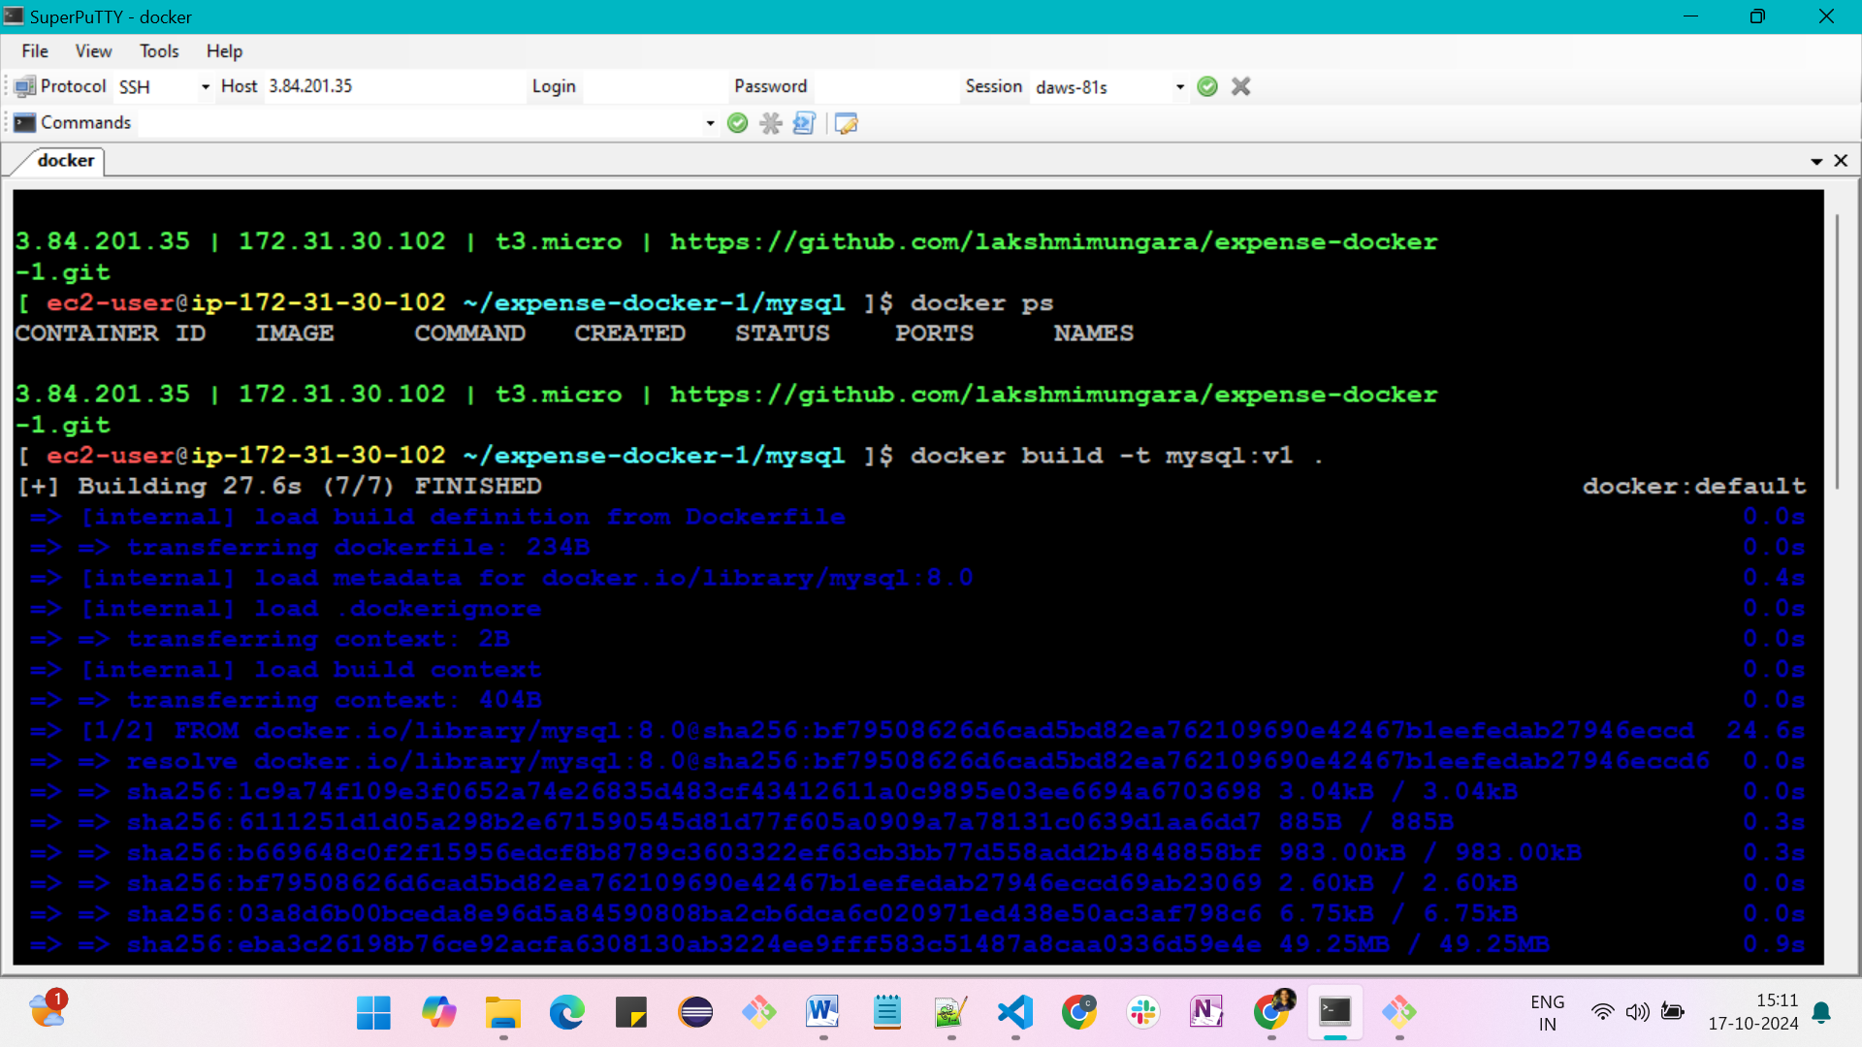

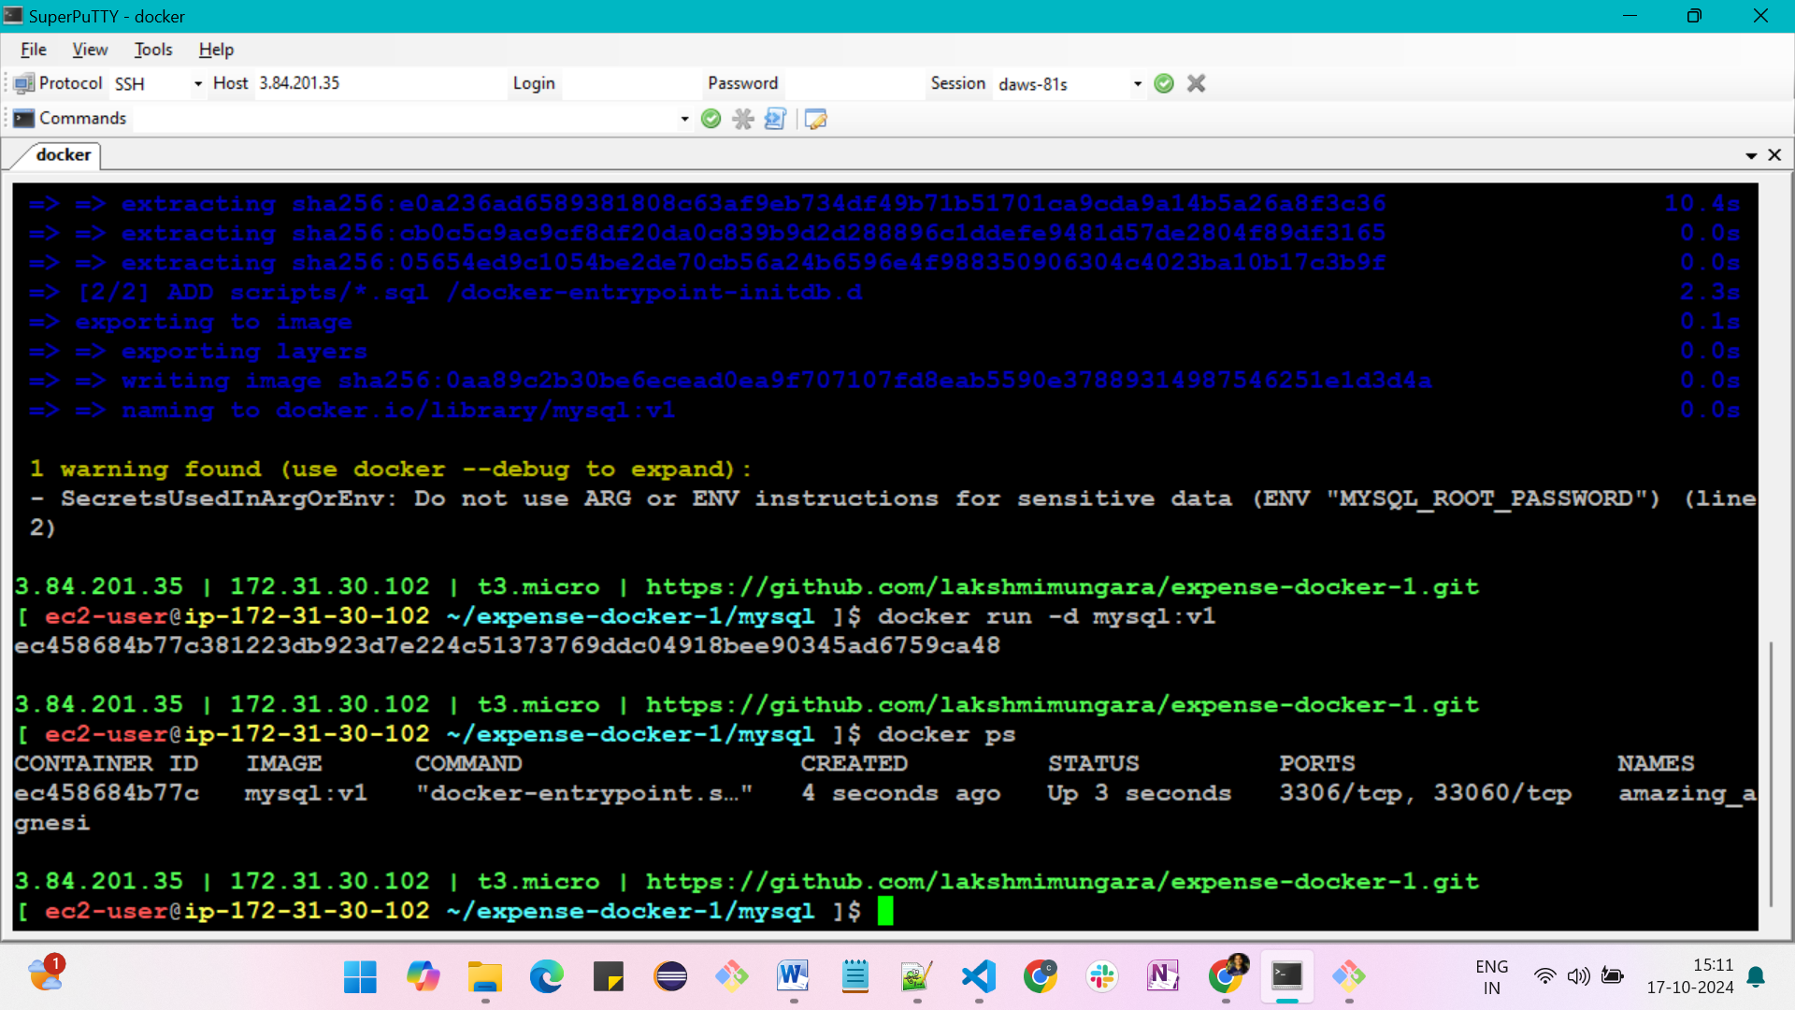

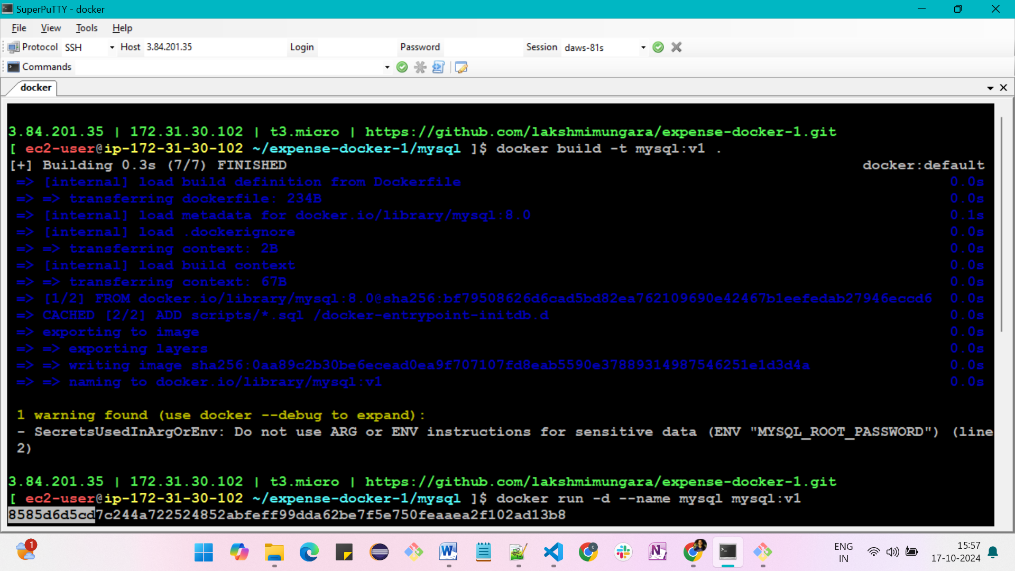

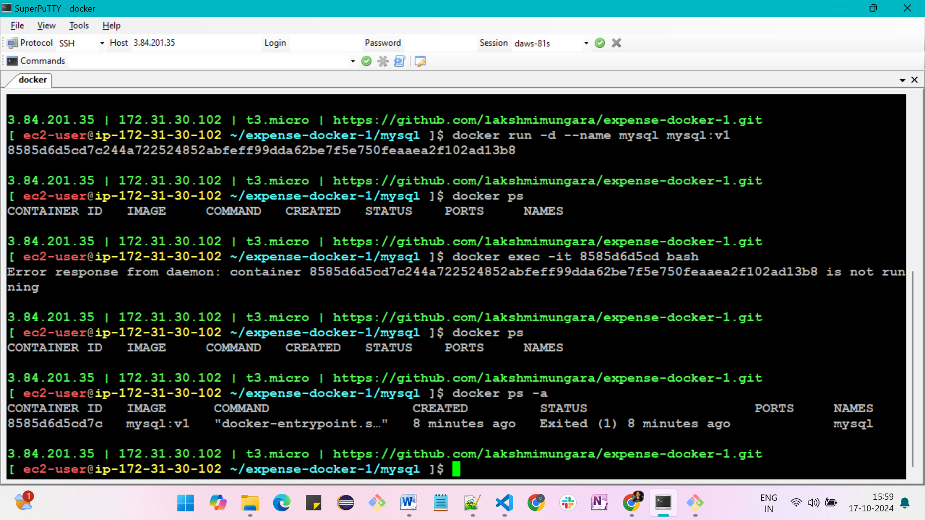

**Before performing backend, we should increase our disk space by following some commands**

**resize the disk**

* sudo su -
* lsblk
* sudo growpart /dev/nvme0n1 4
* sudo lvextend -l +50%FREE /dev/RootVG/rootVol
* sudo lvextend -l +50%FREE /dev/RootVG/varVol
* sudo xfs_growfs /
* sudo xfs_growfs /var
* df –hT

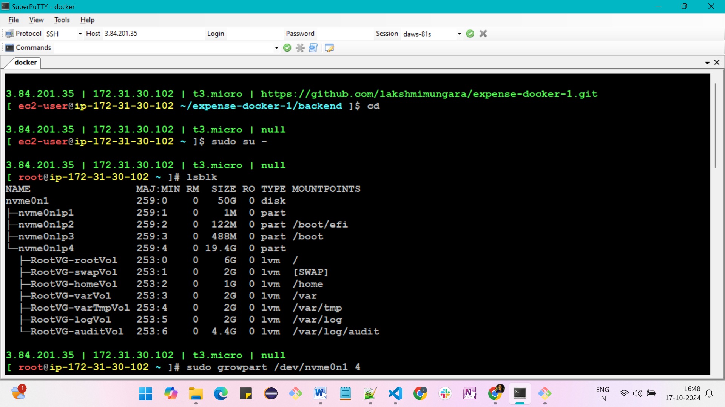

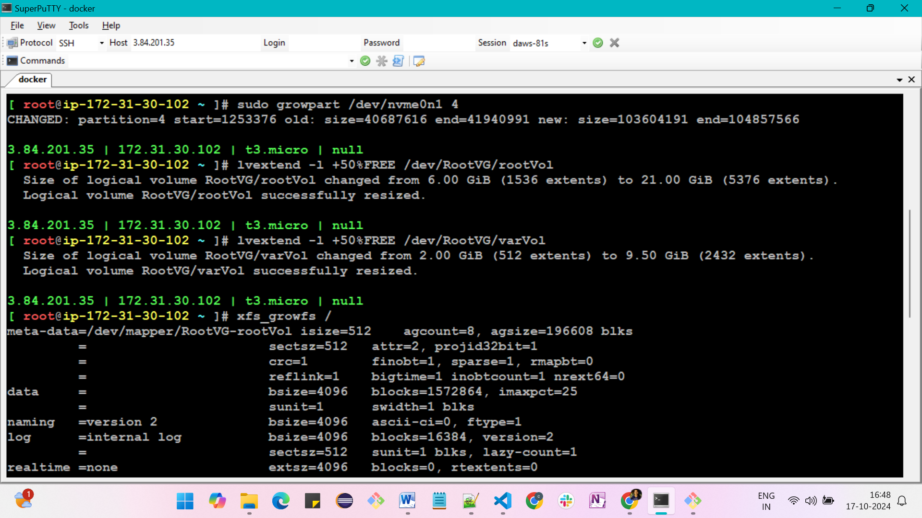

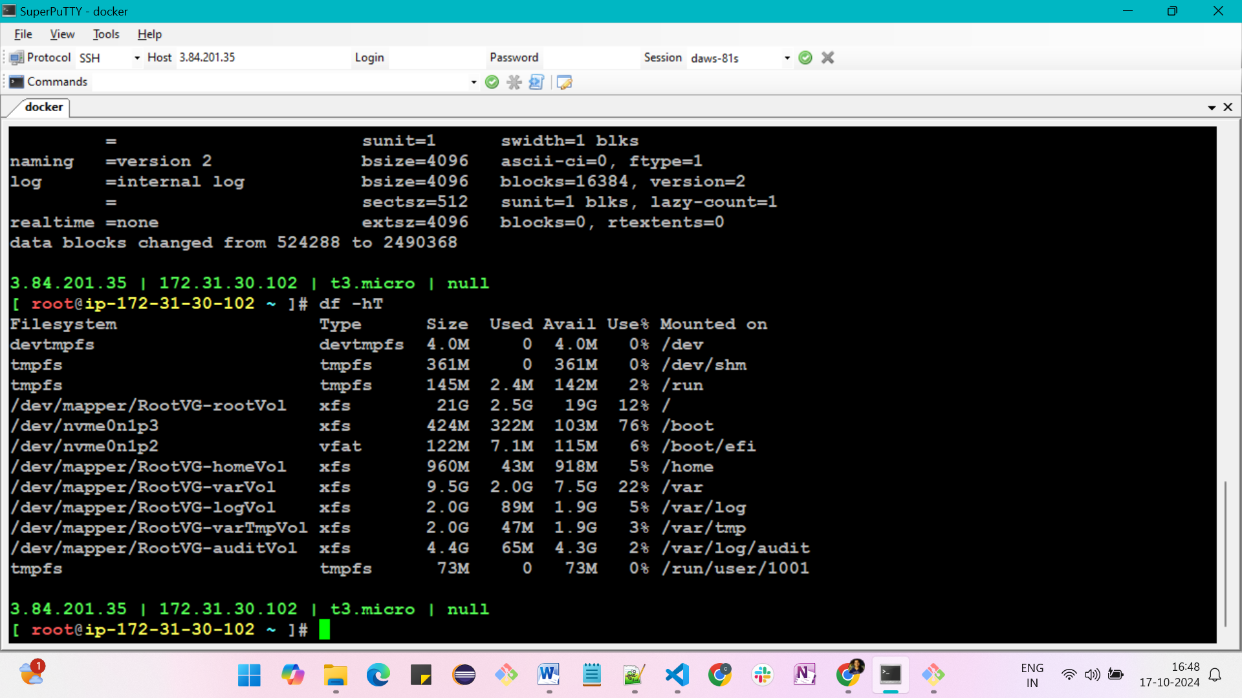

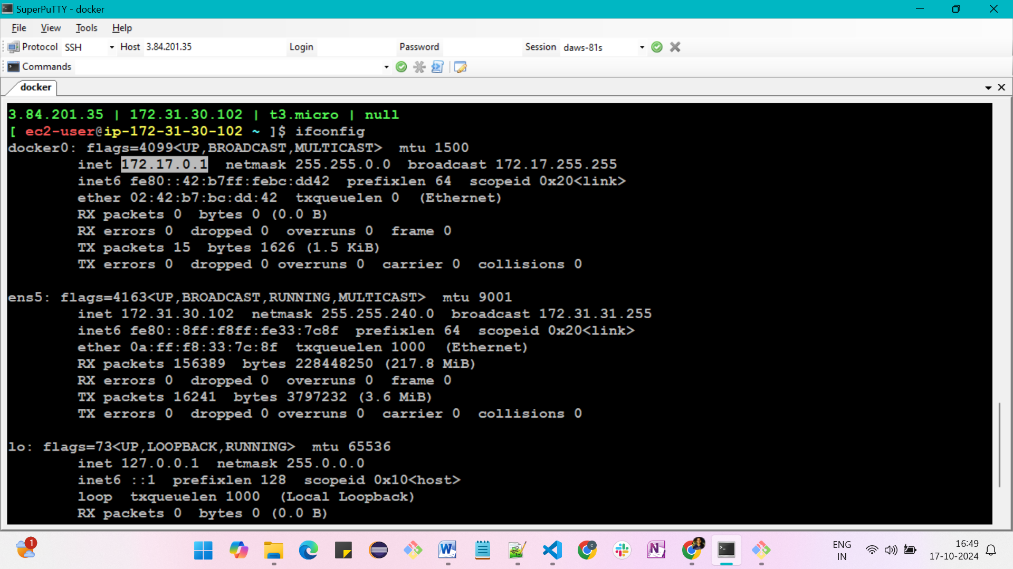

**Now backend**

**Open expense-documentation ->** https://expense-builds.s3.us-east-1.amazonaws.com/expense-backend-v2.zip

Download the files with the above url and copy them in your vs code

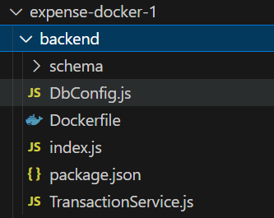

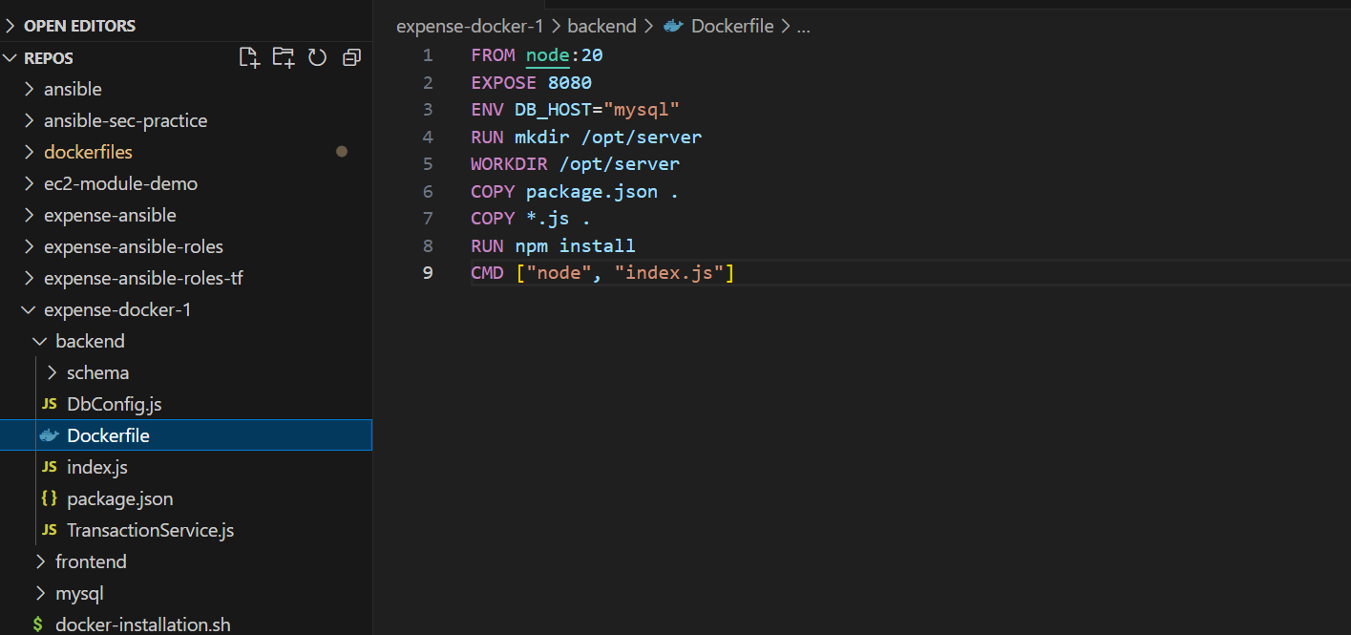

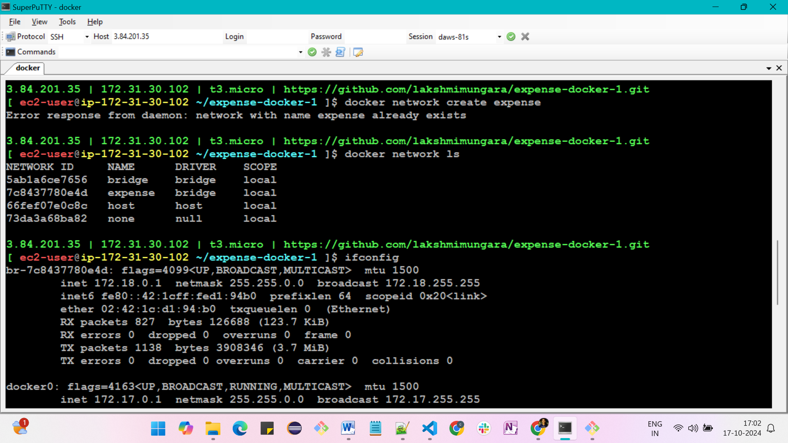

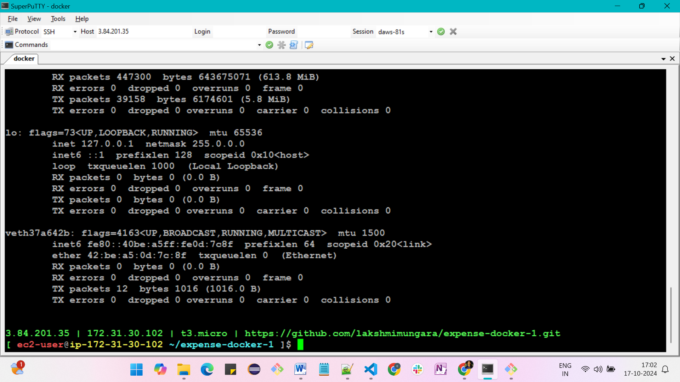

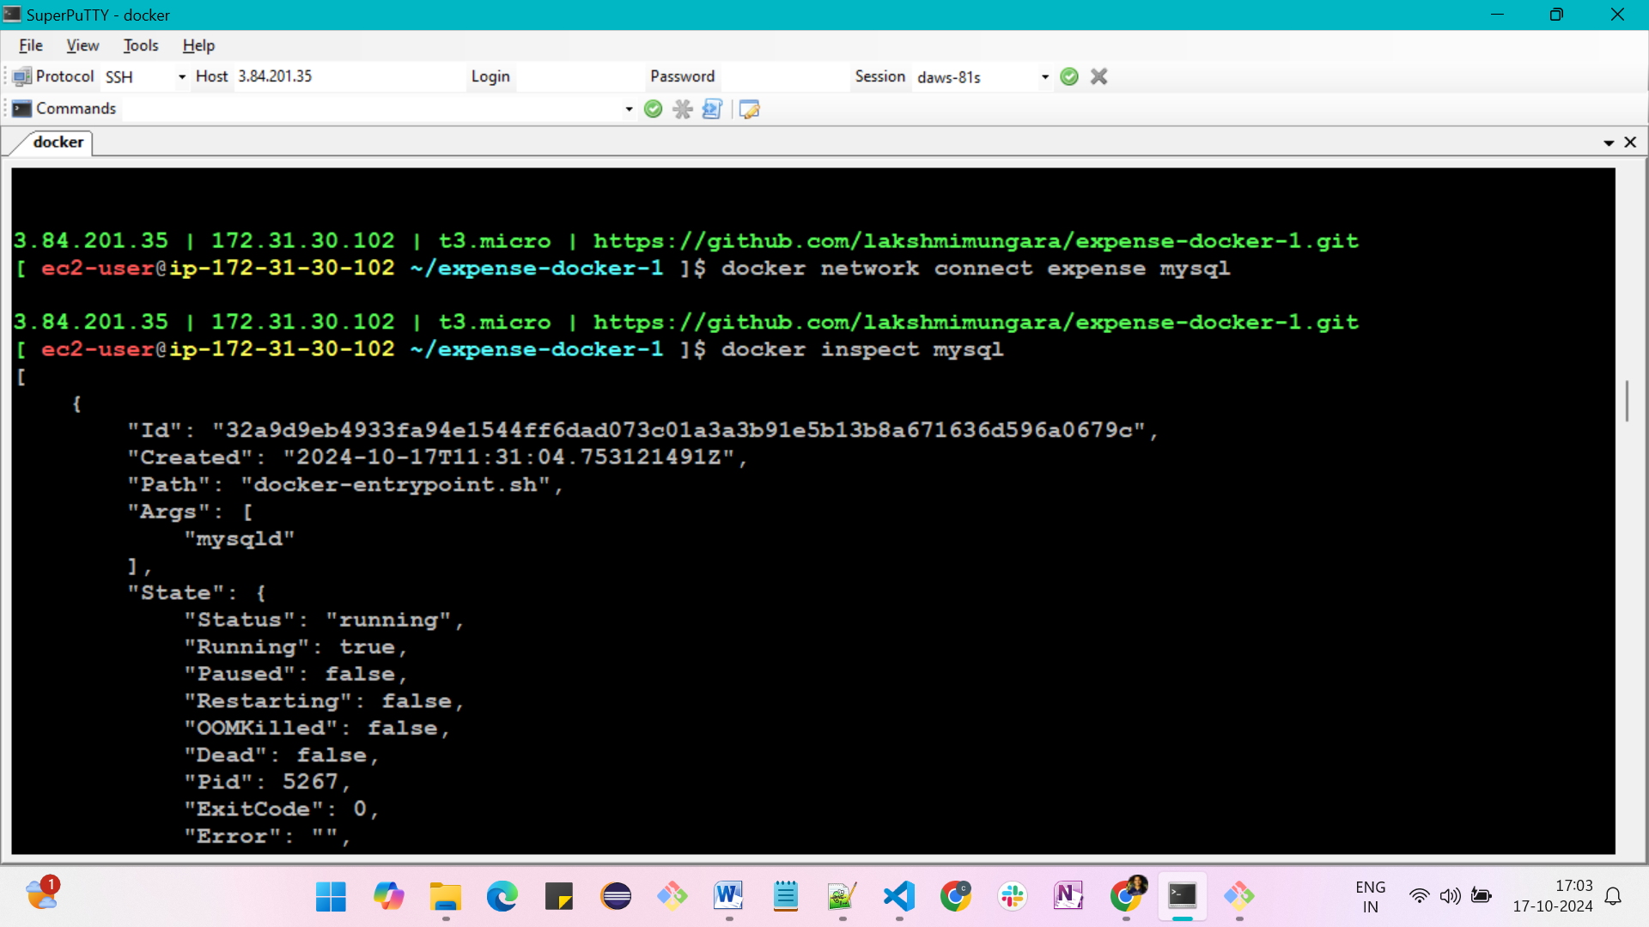

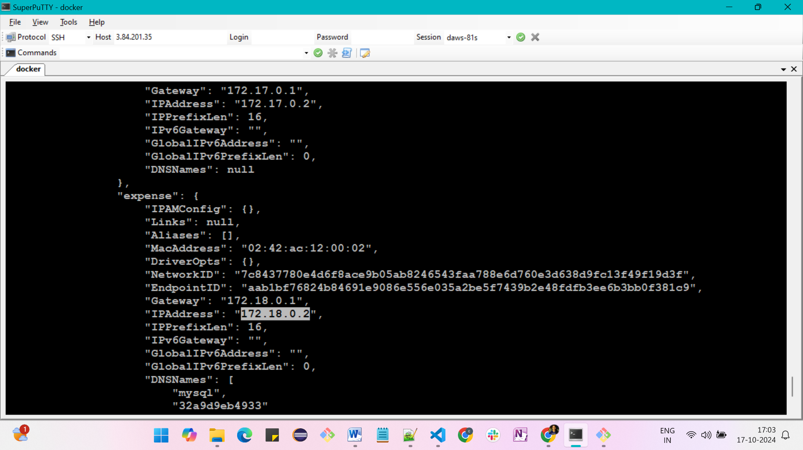

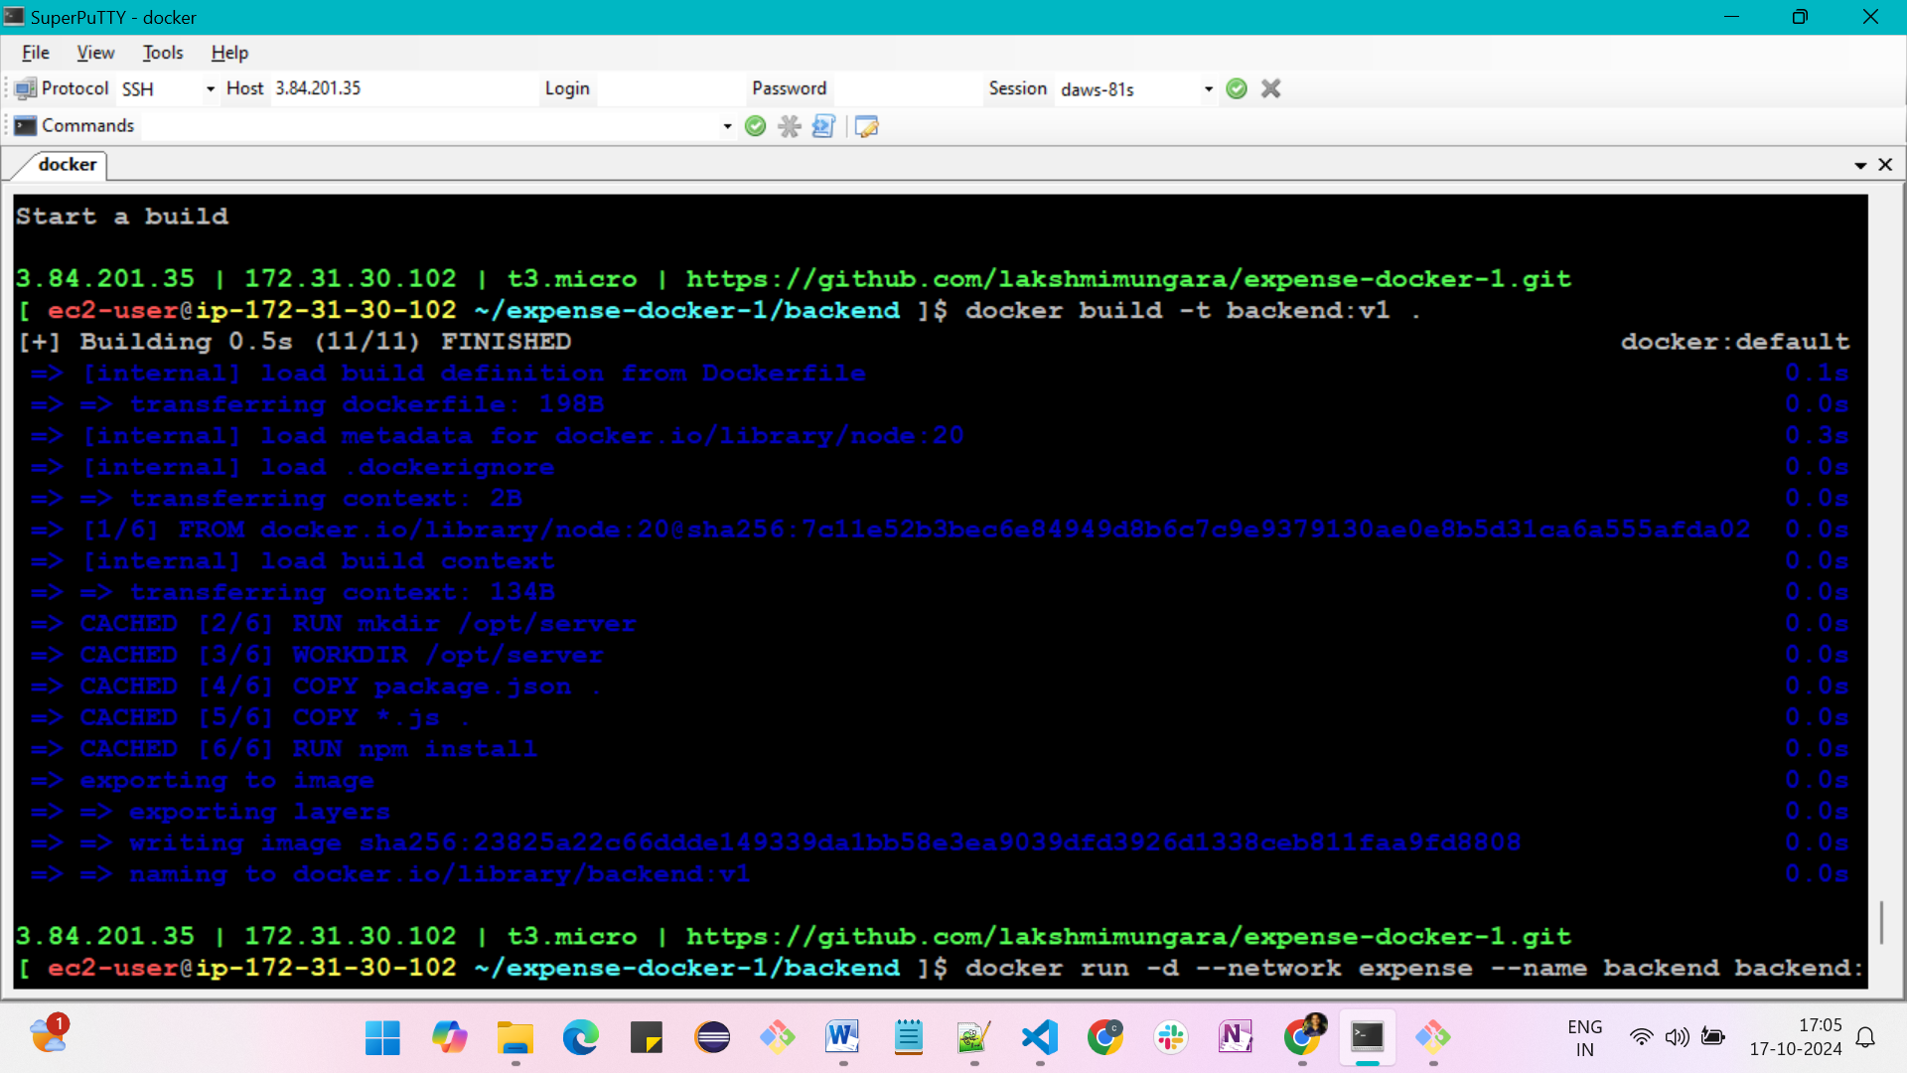

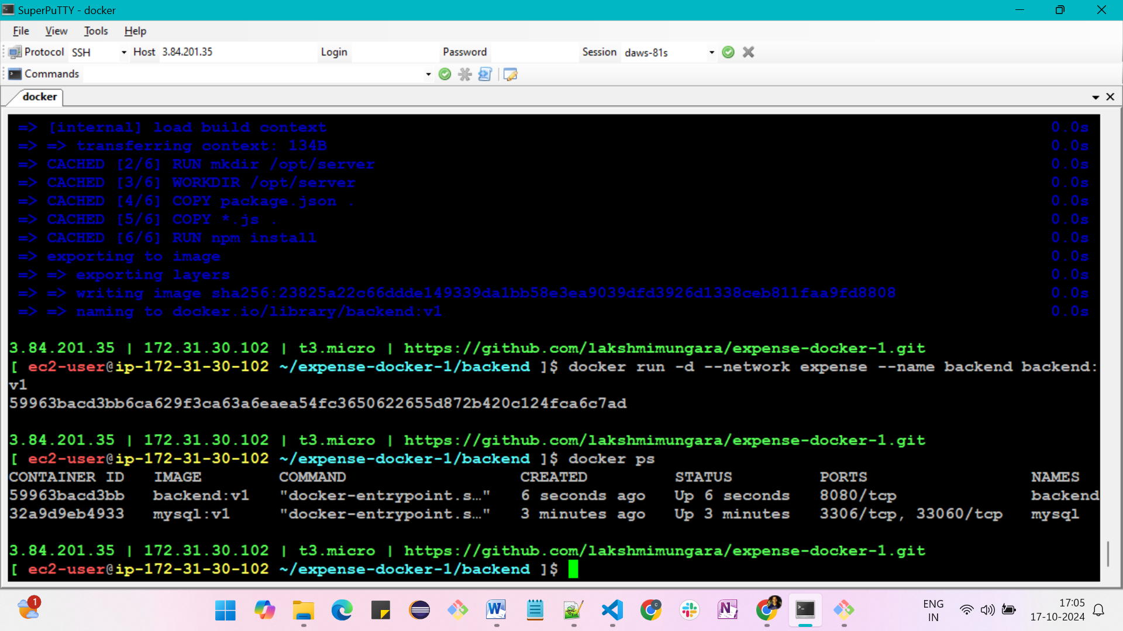



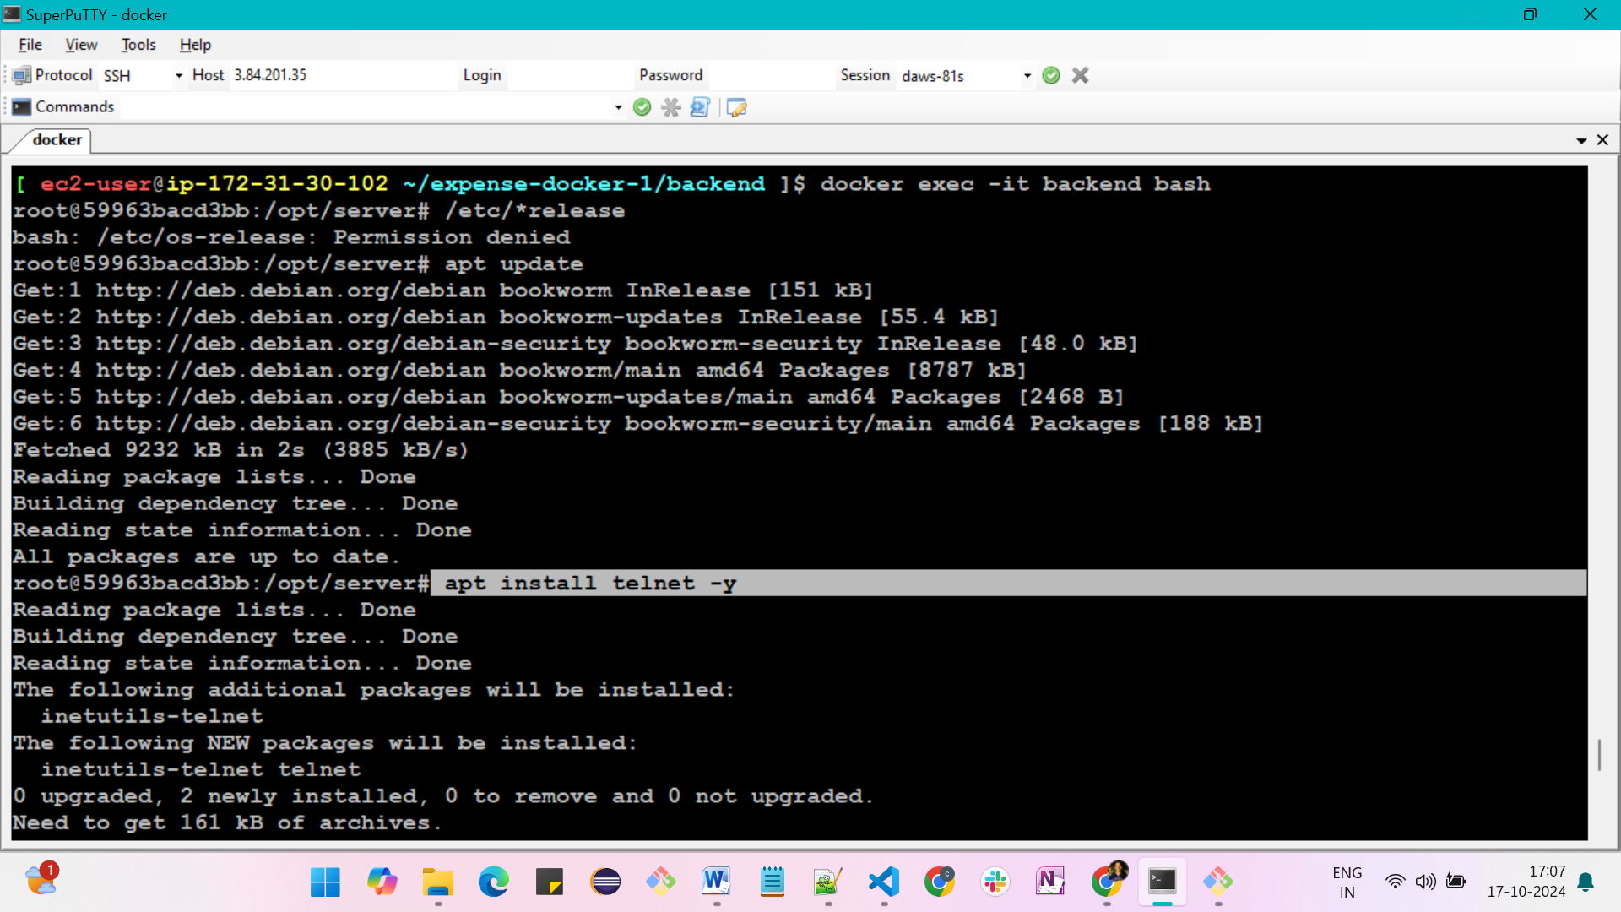

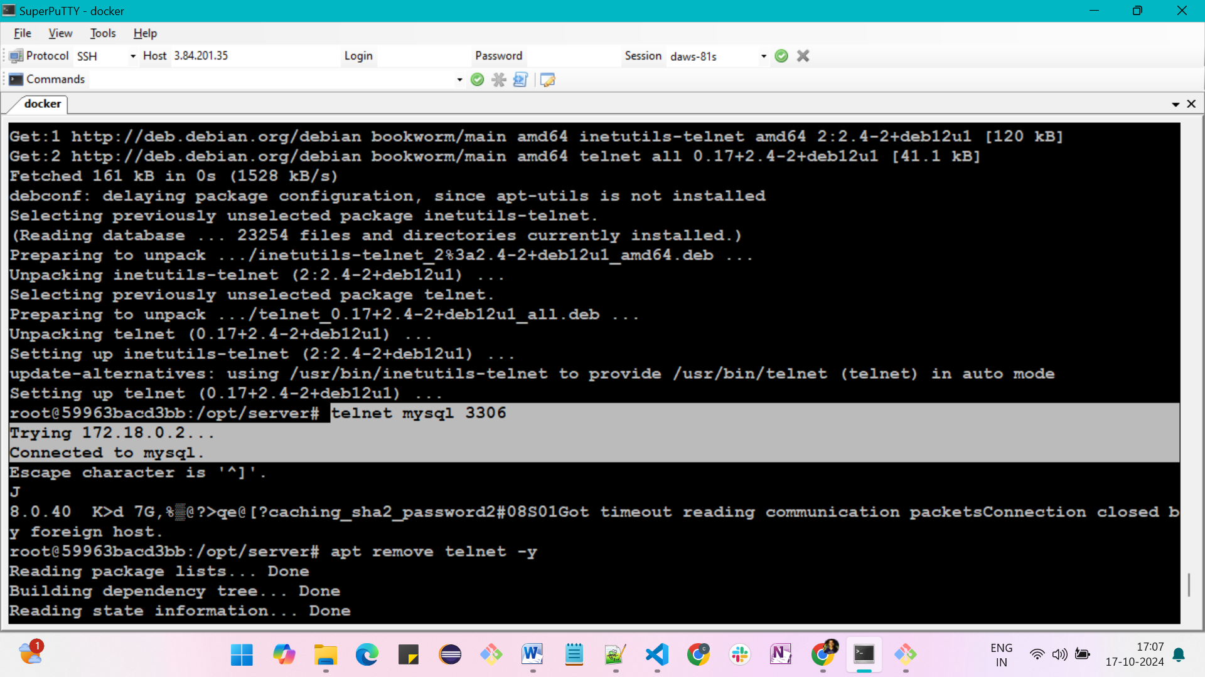

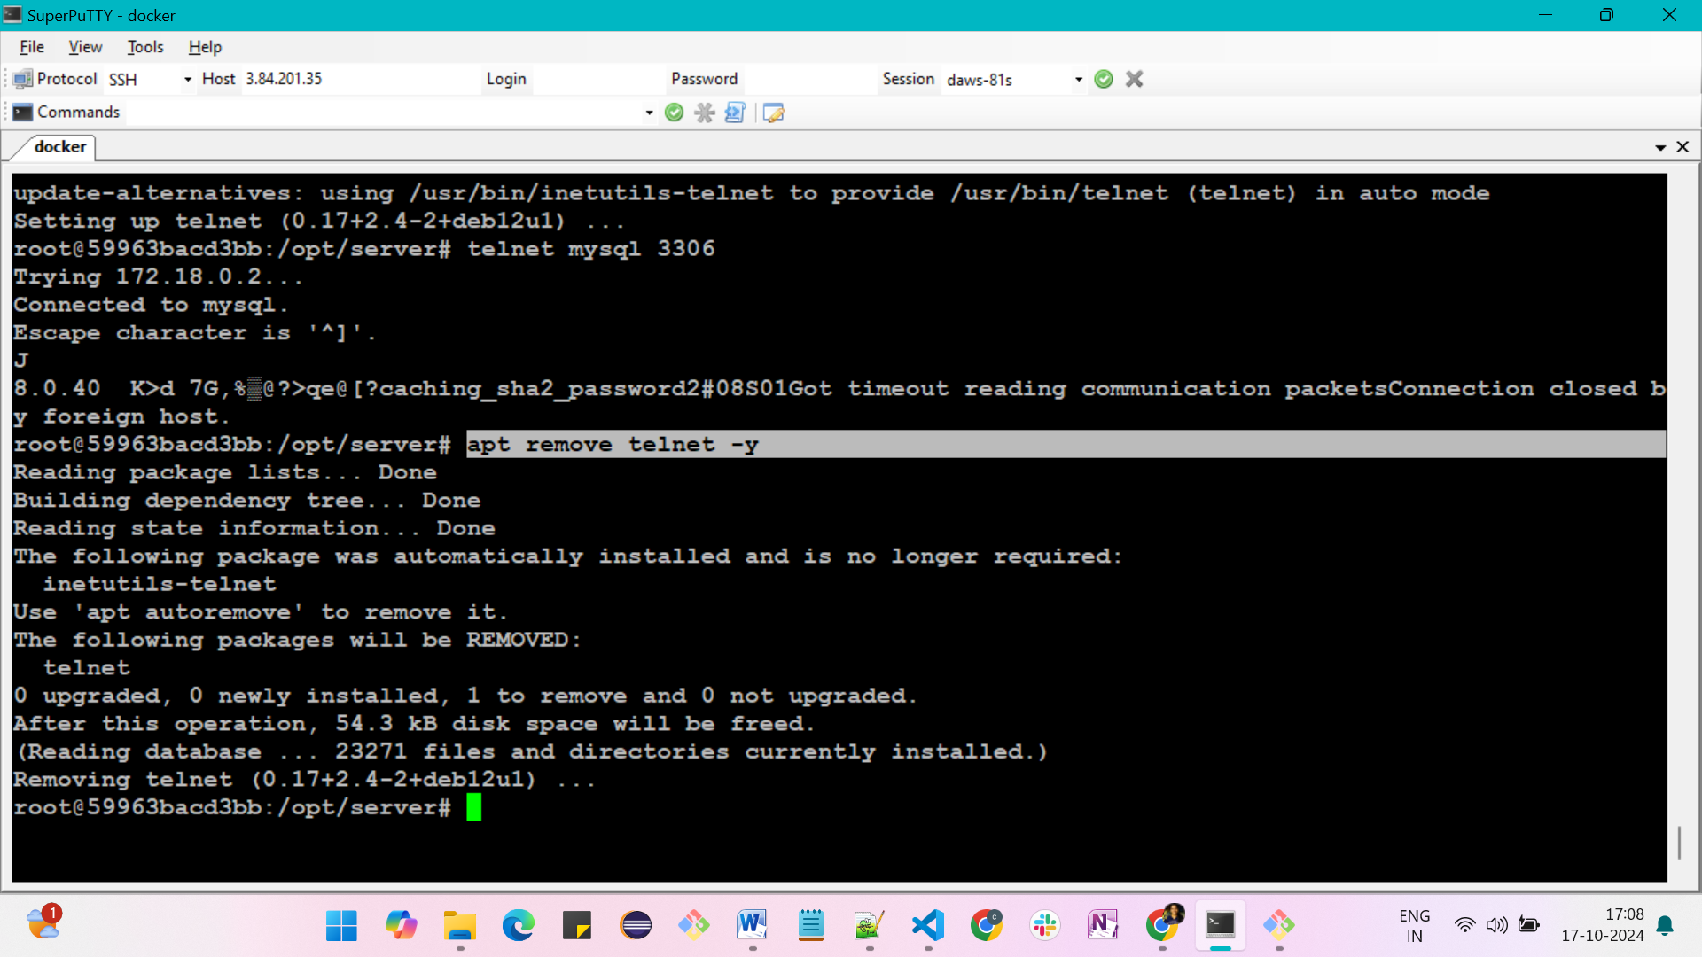

**Now frontend**

**Open our expense project documentation**

**https://expense-builds.s3.us-east-1.amazonaws.com/expense-frontend-v2.zip**

**After downloading we will get some files**



